PROJECT DOCUMENTATION

Title:
SUPPLY CHAIN ANALYTICS DASHBOARD

Submitted By: U. YOGA, B.Sc. IT

Abstract:
The Supply Chain Analytics Dashboard is designed to analyze supply chain operations. The dashboard provides insights into business performance through four major analytical areas: Executive Overview, Sales & Inventory, Manufacturing & Quality, and Supply Chain & Logistics.
The Executive Overview dashboard presents high-level KPIs such as total revenue generated, production volume, manufacturing cost, and defect rate to support strategic decision-making. The Sales & Inventory dashboard helps monitor product sales, stock levels, product availability, and customer demographics. The Manufacturing & Quality dashboard focuses on production efficiency, manufacturing costs, lead times, and quality inspection results. The Supply Chain & Logistics dashboard analyses shipping costs, transportation modes, supplier lead times, and logistics performance.
Interactive filters and visualizations are used to enable users to explore data effectively and identify trends, operational bottlenecks, and improvement opportunities. This project demonstrates how business intelligence tools can transform raw supply chain data into meaningful insights, helping organizations improve operational efficiency, reduce costs, and support data-driven decision-making.

INTRODUCTION
Supply chain management plays a crucial role in ensuring the efficient movement of products, information, and resources within an organization. Effective supply chain operations help businesses reduce costs, improve customer satisfaction, optimize inventory levels, and enhance overall productivity. As organizations generate large volumes of operational data, there is a growing need for business intelligence tools to transform raw data into meaningful insights for better decision-making.
This project presents a Supply Chain Analytics Dashboard developed using Tableau to analyse key aspects of supply chain performance. The dashboard is divided into four sections: Executive Overview, Sales & Inventory, Manufacturing & Quality, and Supply Chain & Logistics. Through interactive visualizations and KPIs, the dashboard enables users to monitor business performance, identify trends, evaluate operational efficiency, and support data-driven decision-making across the supply chain.

- System Requirements:

Hardware Requirements:
- Processor: Intel Core i3 or above
- RAM: 4 GB or above
- Storage: 20 GB Free Disk Space
- Display: 1366 × 768 Resolution or Higher
Software Requirements:
- Operating System: Windows 10 / Windows 11
- Microsoft Excel
- Tableau Public 2026.2

- Software Analysis:

Microsoft Excel:
Microsoft Excel is used for data cleaning and preprocessing. Duplicate values, missing records, data formatting issues and inconsistencies are corrected before importing it into Tableau.

Tableau Public:
Tableau Public is a business intelligence and data visualization tool used for creating interactive dashboards and reports. It enables users to connect data sources, perform data analysis, and visualize information through various charts, graphs, and dashboard components. Tableau provides a drag-and-drop interface that simplifies the process of transforming raw data into meaningful insights. In this project, Tableau Public is used to develop Supply Chain Analytics Dashboards for monitoring sales, inventory, manufacturing, quality, and logistics performance through interactive visualizations and key performance indicators (KPIs).

- SYSTEM DESIGN
Data Collection:
The supply chain dataset is collected from an open-source platform. The dataset contains information related to product sales, inventory, manufacturing, quality inspection, suppliers, logistics, and transportation operations.
Data Preprocessing:
The collected dataset is cleaned using Microsoft Excel. Duplicate records, missing values, formatting inconsistencies, and data quality issues are identified and corrected. The date field is formatted appropriately to support trend analysis and time-based visualizations.
Data Modelling:
The cleaned dataset is imported into Tableau Public. Relevant measures and dimensions are identified and organized for analysis. Calculated fields and aggregations are used to derive key performance indicators (KPIs) such as total revenue, production volume, manufacturing cost, defect rate, shipping cost, and supplier lead time.
Dashboard Development:
Interactive dashboards are created using KPI cards, bar charts, line charts, donut charts, and filters to visualize supply chain insights. The dashboards are categorized into Executive Overview, Sales & Inventory, Manufacturing & Quality, and Supply Chain & Logistics for effective business analysis.

- DATASET DESCRIPTION

Supply Chain Dataset:
The dataset contains information related to various supply chain activities, including product sales, inventory management, manufacturing operations, quality inspections, supplier performance, and logistics management.
Product Information:
Contains product-related details such as Product ID, Product Type, Price, Availability, and Stock Levels.
Sales Information:
Contains sales-related details including Revenue Generated, Number of Products Sold, Customer Demographics, and Order Quantities.
Manufacturing Information:
Contains manufacturing-related details such as Production Volumes, Manufacturing Lead Time, Manufacturing Costs, and Operational Lead Time.
Quality Information:
Contains quality-related details including Inspection Results and Defect Rates.
Logistics Information:
Contains logistics and transportation details such as Shipping Carriers, Shipping Costs, Shipping Times, Transportation Modes, Routes, Supplier Names, Supplier Lead Time, and Overall Transportation Costs.
Date Information:
Contains the transaction date used for trend analysis and time-based reporting.

- DASHBOARD OUTPUT

Dashboard 1 – Executive Overview
The Executive Overview dashboard provides a high-level summary of supply chain performance. It displays key metrics such as total revenue generated, production volume, manufacturing cost, and defect rate. Interactive visualizations help management quickly understand overall business performance, identify trends, and support strategic decision-making.

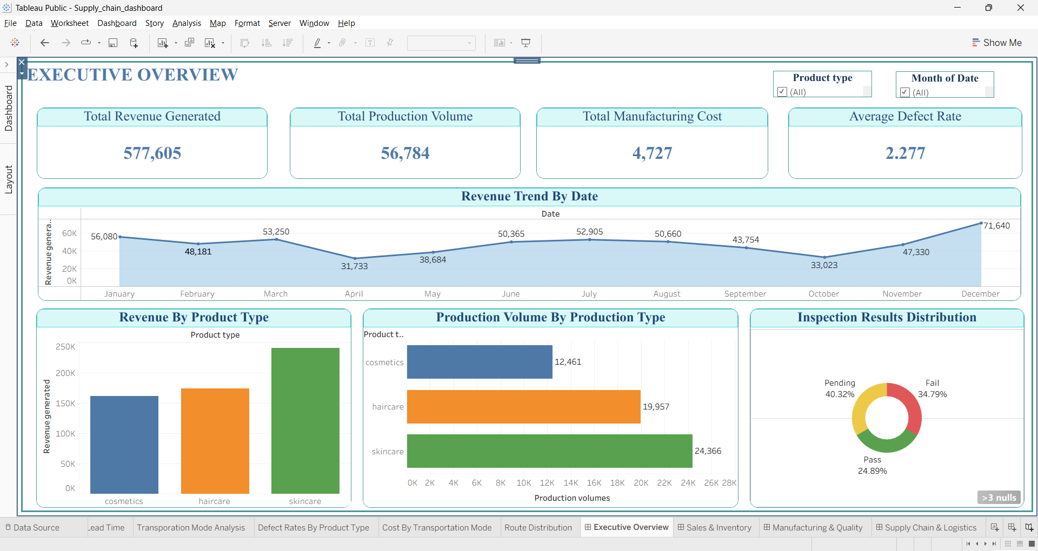

Dashboard 2 – Sales & Inventory
The Sales & Inventory dashboard focuses on product sales performance and inventory management. It analyses products sold, stock levels, product availability, and customer demographics. The dashboard helps identify high-performing products, monitor inventory status, and support efficient inventory planning and sales analysis.

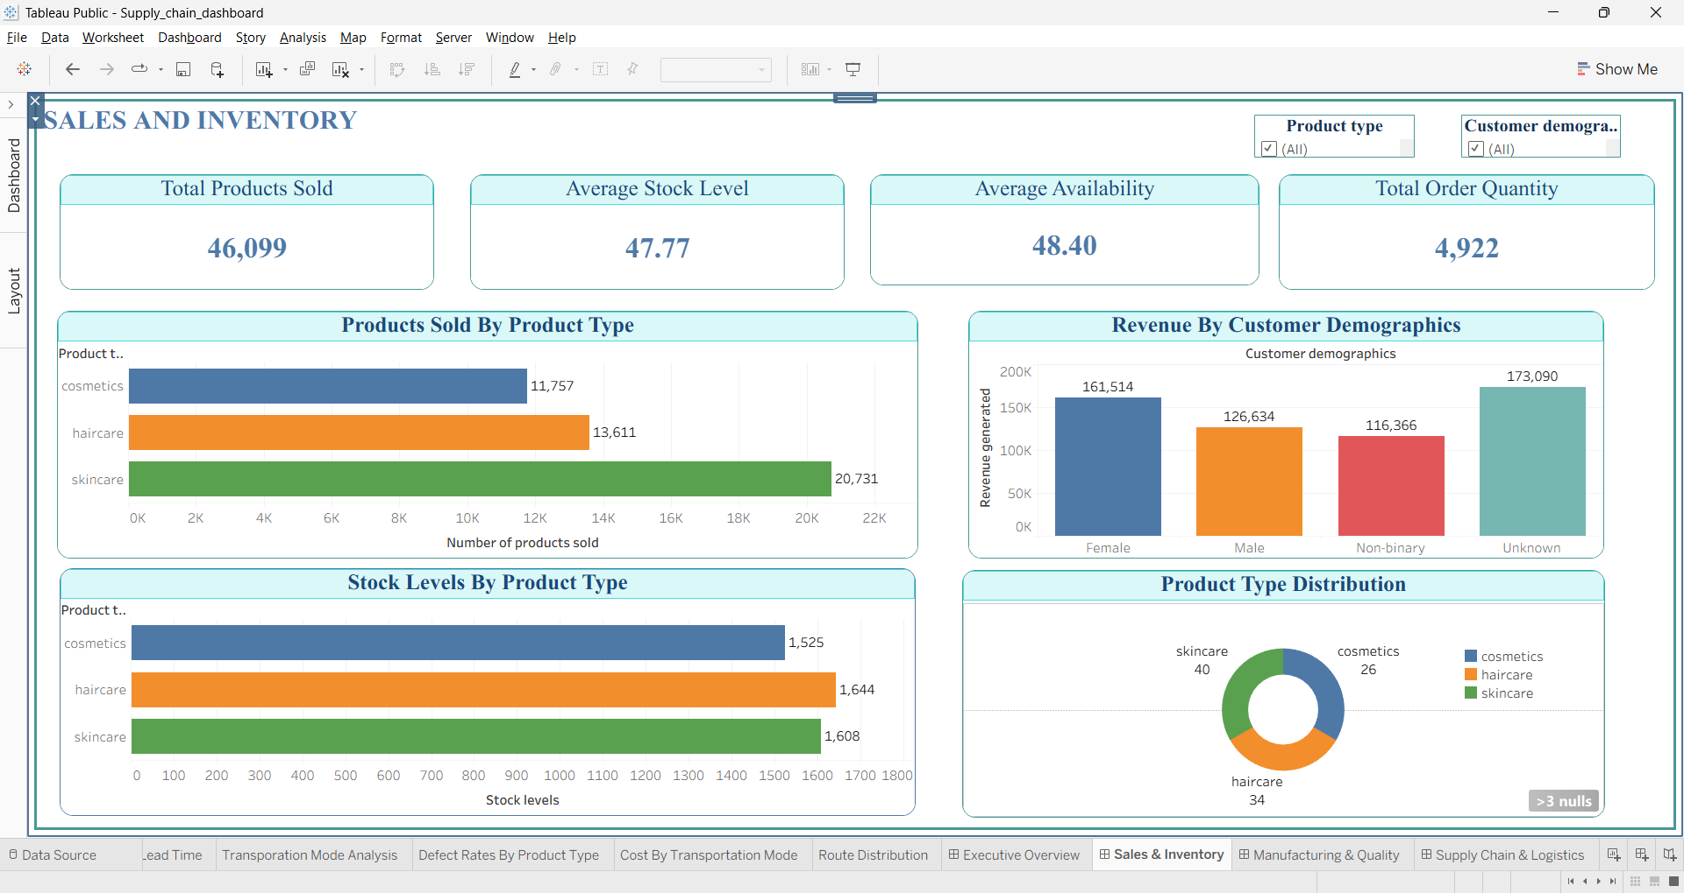

Dashboard 3 – Manufacturing & Quality
The Manufacturing & Quality dashboard evaluates production efficiency and product quality. It presents metrics related to production volume, manufacturing cost, lead time, defect rates, and inspection results. This dashboard helps identify quality issues, monitor manufacturing performance, and improve operational efficiency through data-driven insights.

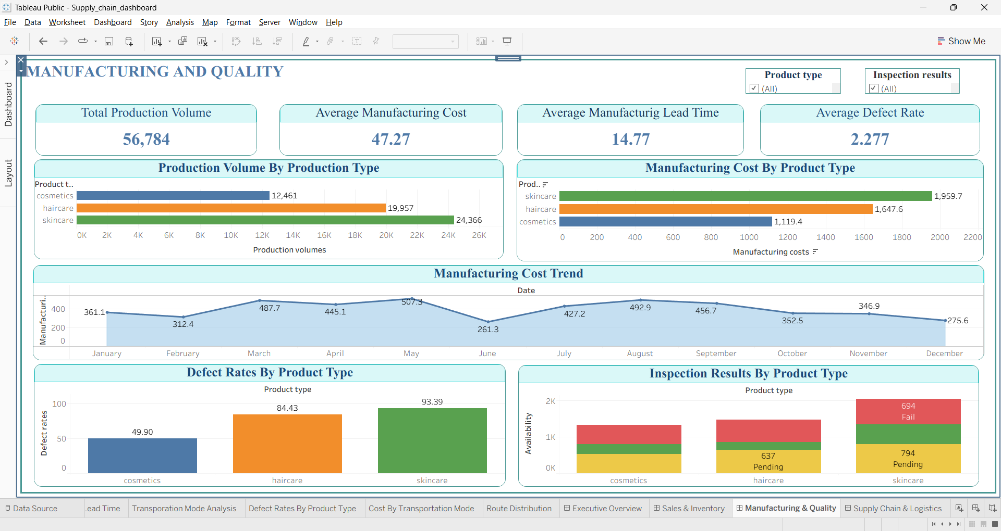

Dashboard 4 – Supply Chain & Logistics
The Supply Chain & Logistics dashboard analyses logistics operations and supplier performance. It includes metrics such as shipping cost, shipping time, supplier lead time, transportation cost, and route distribution. The dashboard helps organizations optimize logistics processes, reduce operational costs, and improve overall supply chain efficiency.

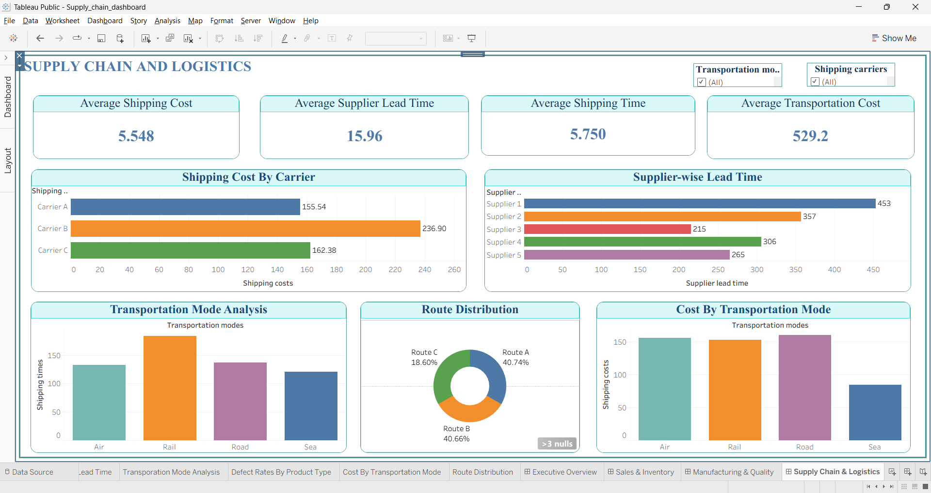

- CONCLUSION
The Supply Chain Analytics Dashboard was successfully developed using Tableau Public to analyse and visualize key supply chain operations. The dashboard provides valuable insights into revenue generation, inventory management, manufacturing performance, product quality, and logistics activities. Through interactive visualizations and KPI monitoring, users can easily identify trends, evaluate operational efficiency, and make informed business decisions. The project demonstrates the importance of data visualization in transforming raw data into meaningful and actionable insights for effective supply chain management.

- FUTURE ENHANCEMENTS

• Integration with real-time supply chain data sources.
• Predictive analytics for demand and inventory forecasting.
• Advanced supplier performance and risk analysis.
• Interactive drill-down reports and enhanced filtering options.
• Automated KPI alerts for operational monitoring.
• Deployment through Tableau Public/Server for online access and collaboration.

